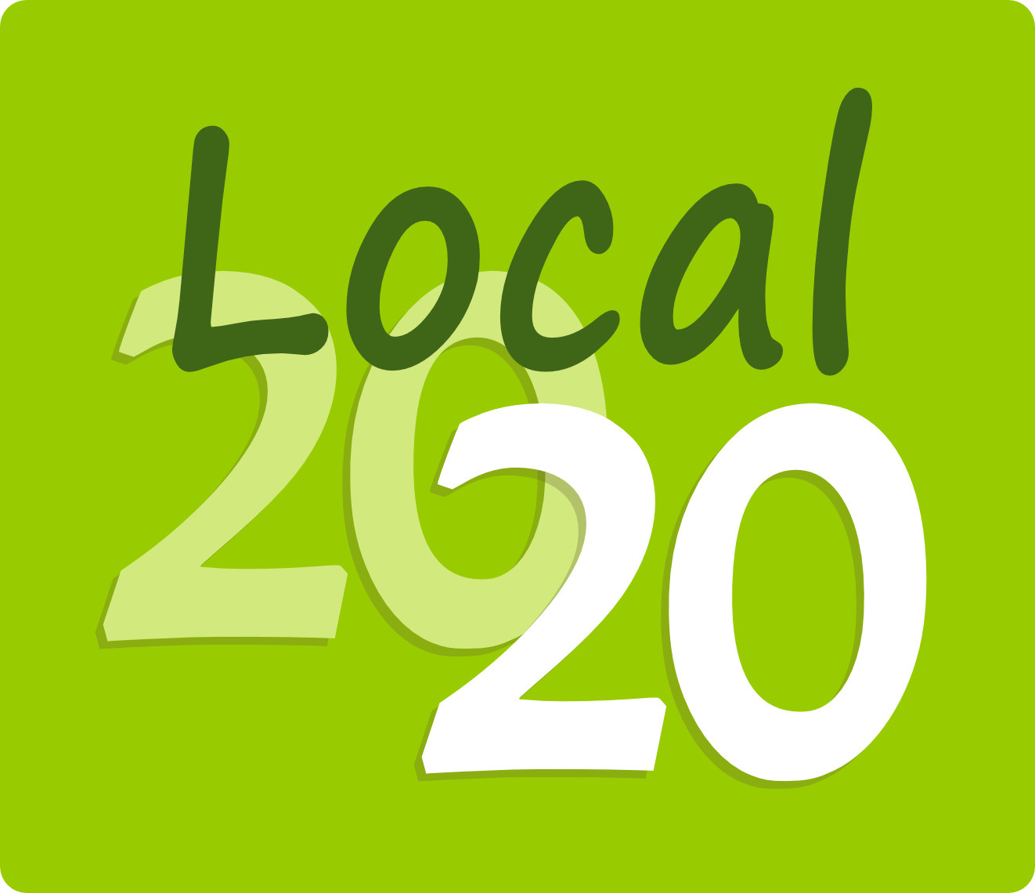
COVID-19 & The Future of Jefferson County:
A Creative Visioning Exercise

Context

The COVID-19 emergency has at least temporarily, and most likely over the long-term, changed the shape of our daily lives and our communities. Threats to our health, to our homes and family structures, and to our economic security have emerged, on a local, state, national, and global level. Other challenges are ongoing issues in Jefferson County that will continue to affect our homes, farms, and businesses.

Crises like these bring to light both the strengths and weaknesses of our communities and current ways of life, and cause us to reflect on what we could be doing differently. When communities are forced to rebuild from a crisis, it provides an opportunity to reshape ourselves into what we want to be, rather than simply reacting to an emergency or continuing along our current path.

We would like to engage the entire community in this opportunity to positively imagine a future for ourselves and Jefferson County. The ability to envision a positive future when times are hard can help relieve stress and give us all something to work toward. The results of this effort will be gathered and distributed widely throughout the county, and will help shape where we collectively go from here.

WE WANT TO HEAR YOUR EXPERIENCES, IDEAS, AND SUGGESTIONS

Imagine a future, say 5-10 years from now, when our community has recovered from the health, emotional, and economic effects of the COVID-19 emergency and is more resilient and sustainable - the best possible future for our families, farms, communities, and businesses in Jefferson County.
Imagine it as if you were there now. What does it feel like? What do you see and experience as you visit familiar places? What is gone and what is new? What surprises you? And how can we get there from here?
In the next few pages:
- Describe what is happening to you now, during this current crisis.
- Tell us what you’d like to see in our future community.
- Identify existing strengths and weaknesses, challenges and opportunities that affect our ability to bring this about.
- Tell us your priorities for where to start.

~ You may fill out all sections or only those questions that interest you. ~

Please return your responses to:
survey@l2020.org
or
Local 20/20, 1240 W Sims Way #12
Port Townsend, WA 98368
WHAT’S HAPPENING NOW?

How has this crisis affected you? What are you experiencing?

Have any positive changes been made during this crisis that we may want to keep or build on (for example, greater access to telemedicine)?

WHAT IS YOUR VISION FOR OUR COMMUNITY?

Describe our community in the future as you imagine it could be.

What values would you like our community to keep uppermost as we make changes for the future?

What resources would you like our community to have?

HOW CAN WE BRING ABOUT THE FUTURE WE WANT?

What are the existing challenges in reaching this vision, either pre-existing or COVID-related?

What strengths or resources does our community already have that we could build on?

TURNING THE VISION INTO REALITY

What is the FIRST thing you would like people to focus on?

In your opinion, what are the other 3 to 5 highest priorities to work on?

ANYTHING ELSE YOU WOULD LIKE TO SHARE OR COMMENT ON? (Feel free to add additional sheets).

TELL US ABOUT YOURSELF
(optional and confidential)

Age:

Where you live (zipcode and community, ex. Cape George, Brinnon, etc.):

How did you hear about this survey?

STAY IN TOUCH

If you’d like to receive the results of this community-wide conversation, please let us know how you’d like us to send it. YOUR PERSONAL INFORMATION WILL NOT BE PLACED ON ANY MAILING LIST OR DIVULGED TO ANYONE. It will only be used to send you the report. We will also post the report on the Local 20/20 website and include a notice in the Local 20/20 weekly announcements.

Please mail the report to me

Please send the report electronically

I will access it when it is posted on the Local 20/20 website

If by e-mail or mail, my e-mail or mailing address is:

DO WE HAVE YOUR PERMISSION TO ANONYMOUSLY INCLUDE YOUR IDEAS AND RESPONSES IN THE REPORT? Responses will be grouped and compiled in a format that does not identify the author, but we may want to use some direct quotes if it helps illustrate the ideas. (Yes, No, any comments)

_______________________________

THANK YOU FOR PARTICIPATING!!

